**Schedule 1 - Scope of Works**

**For Access control and CCTV systems upgrade**

# ABBREVIATIONS

* NSRP: Nghi Son Refinery and Petrochemicals
* ADB: Administration Building
* CCB: Central Control Building
* HA: High Availability
* SAN: Storage Network Area
* HSE: Health Safety and Security Environment
* ACS: Access Control System
* S- CCTV: Security Closed-Circuit Television
* MGH: Main Gate House Building
* NFMS: Network Facility Management System
* NVR: Network Video Recorder
* SOW: Scope of Work

# SCOPE OF WORKS

## Purpose

This document is to define SOW that will be used for Service provider selection

This document describes the SOW for the upgrading Access Control System that provides access control to limit and control the access into the Refinery and upgrading the Security CCTV system that provides remote visual monitoring of company security

## System overview

* **ACS SYSTEM**

A centralized ACS provides access control of personnel and vehicles at the entry points to the Permanent Works, Marine Facility and also at the entrances to key buildings. The primary method of access control is by using individual encoded personnel RFID access security card badges.

Personnel and/or vehicular access control equipment will be installed in the number of gates at the various locations as Main Gate, Truck Loading Gate (Vehicular Access Only). Jetty Main Gate, Plant Area Gate, Employee Plant Area Gate…

Personnel movement can only be accessible by either the acceptance of a valid card or by manual activation from the guard house. The personnel access control comprises of the Personnel Turnstiles

Access Card Readers, Emergency Exit Buttons, intercom Unit linked to Guard House, Guard House Manual Entry Button

Building Door Access requires card swipe and security code for entry access. The ACS door entry equipment including, Central Access Control System Server, Badging Stations with cameras and card printing facilities, Local Access Controllers with network interfaces, Card readers, Keypads , Door locks , Alarms , Door Release Emergency door release (“break glass”) units

ACS controller is interfaced to the fire and gas system in each building. In the event of a fire alarm all protected doors shall be released to allow personnel to exit without needing to card swipe or enter access codes. The ACS is also interfaced to Security CCTV so that the nearest Security CCTV gate cameras are triggered if ACS detects suspicious activity and commence recording.

The Access Control server database is able to maintain records for a minimum of 3000 person and capacity of the server is to handle 5000 entry request per hour.

The ACS system also share data with Human Resource system to manage in/ out coming staffs

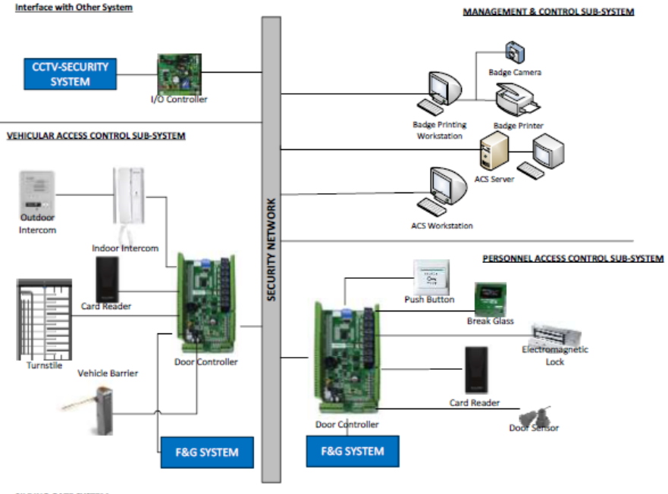

* **SECURITY CCTV SYSTEM (S-CCTV)**

The purpose of Security-CCTV System is to provide monitoring to the Fence with an increased level of security to the NSRP. The S-CCTV consists of two systems which include Fence CCTV system and FiberPatrol Sensor system. CCTV system provides the surveillance while the FiberPatrol Sensor provides the intrusion detection.

S- CCTV system including the main equipment

*  Master Server
*  Network Video Recorders
* Review Workstation
* Keyboards Controllers
* Cameras

The Security CCTV system interfaces with Access Control system (ACS) via dry contact. The ACS system will send alarm signal to Security CCTV system. Based on the alarm input Security CCTV system will activate respective camera to focus to pre-set location to check status about location from where the alarm has been activated. The Security CCTV also interface with NMFMS system is through LAN network. Security CCTV system sends the alarm to NMFMS server which located at central control building via LAN network.

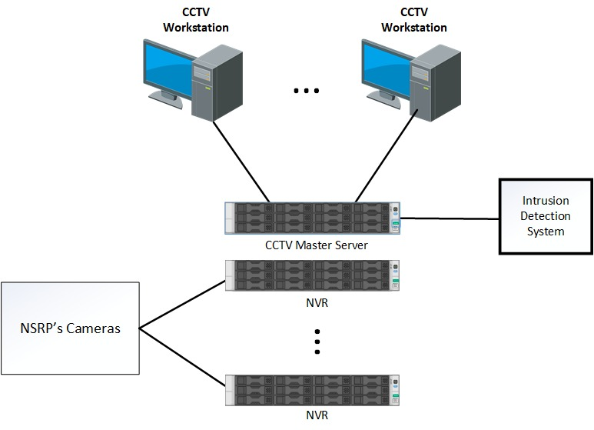

## The System improvement

* **The current system has some limitation**

**ACS**

* One server running standalone with no High Availability.
* Performance of the server is very slow.
* Server is End of Support.
* Operating system (Window 7) does not support since 14/01/2019.
* MSSQL 2015 Express is limitation of 4GB capacity.
* Watchnet software supports Window 32bit only.
* No hardware and software support from Vendors.

**Security CCTV**

* No hardware and software support from Vendor.
* Software does not support full functions of some installed cameras.
* Data is kept in NVRs within 28 days only (maximum)
* One master server running standalone with no High Availability.

NSRP plans to minimum above risks by upgrading Systems and find the Technical support from Vendors with following SOW

* **System improvement**

**ACS**

* Reuse 02 available servers (Dell RX 730) by expansion warranty of these severs for 02 years
* Moving ACS servers from MGH to Admin and CCB buildings.
* VM technology will be used for HA.
* Upgrade OS to Window server 2016 (64 bits).
* Upgrade DB to MS SQL standard (64 bits with unlimited capacity)
* Upgrade Watchnet software on ACS servers to latest version
* Upgrade Watchenet software on ACS clients to latest version
* Migrate data from current servers to new servers
* Purchase 38 HDD disks to expand capacity of the SC 5020 storages
* Support NSRP to solve technical issue relating to ACS system within 5 years (including hardware and software)

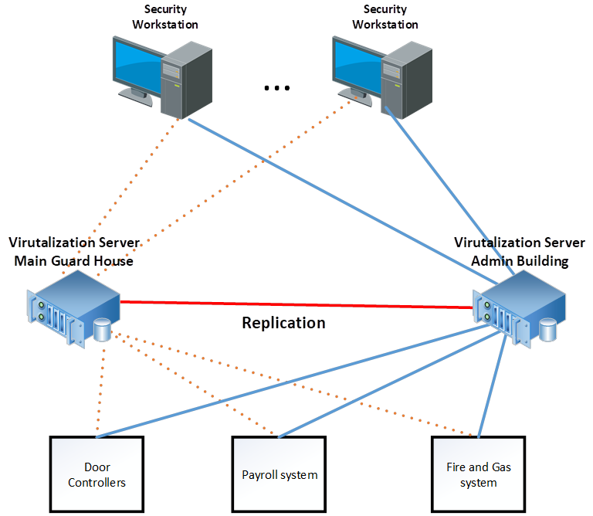

**SCCTV**

**The upgrade CCTV systems will be separated to 02 phases with flowing SOW**

**Phase 1:**

* Increase capacity of the Network Video Recorder to keep Video data for 180 days instead of 28 days.
* Purchase 01 NAS for expansion of the NVRs of S-CCTV
* Purchase 02 distribution switches.
* Install and configuration new storages
* Install additional equipment in Telecom cabinet (electrical beaker, temperate sensors…) and integrate with NFMS system.
* Mapping Video channels of the NVRs to purchased storages
* Support NSRP to solve technical issue relating to S - CCTV system within 5 years (including servers and storage)
* Install alarm devices in the Telecom cabinet/ rack and configure system connection to available NFMS system.

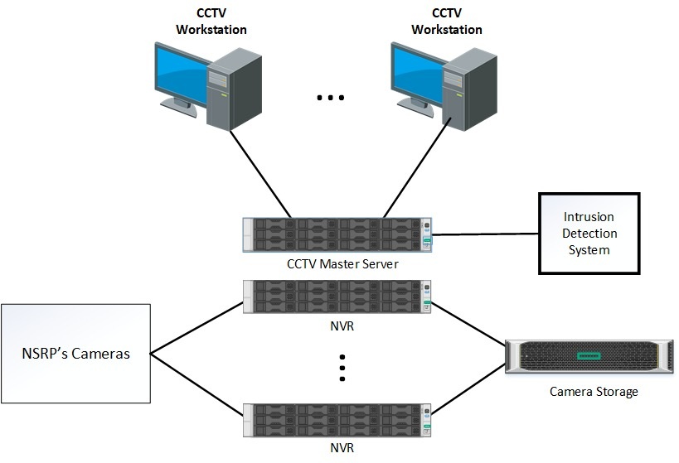

**Phase 2 (*)**

* Build system for HA
* Upgrade/ Replace software
* Expansion capacity of P- SCCTV
* …

**(*) Phase 2 of the S-CCTV is out of scope of this project**

## The sizes, quantities, software version, engineering service, equipment… indicated in this Scope of Work will be used as guideline only. The Service providers shall re-size, verify all devices with its quality, and update of lacking components (if needed) to complete BOM to make sure there is not issue of material during the detail design and implementation phase. The Service providers must optimize the requirements with respect to safety, operability, reliability, and life-cycle costs of the provided services set out in this Scope of Works and submit to NSRP for approval. Any deviation to the Original Requirements shall require NSRP’s approval prior to implementation.

## Bill of Material (*)

It is requested Service providers to provide Bill of Material (BOM) document with below information. Bidder will be disqualified if bidder fail to provide any of below item.

(*) - NSRP plans to utilize available servers, so purchasing servers for ACS system is excluded on this BOM but we need to expand warranty for these servers

- Window server OS (Window server 2012/2016), Window client OS (Window 10 Pro) , MSSQL Data (MS SQL 2012/2016) base are available, so they are not included on this BOM

- NSRP already has ACS software license (dongle key), so it is not included on this BOM

|  |  |  |  |
| --- | --- | --- | --- |
| **No./PN** | **Description** | **Qty** | **Unit** |
| **1** | **CCTV Storage** |  |  |
|  | **Dell EMC ME4084 Storage Array** | **1** | set |
|  | 12TB HDD 7.2K 512e SAS12 3.5 | 56 |  |
|  | 12Gb SAS 8 Port Dual 5U Controller | 1 |  |
|  | Power Supply, 2200W, Redundant | 1 |  |
|  | Rack Power Cord 2.5M | 2 |  |
|  | 12Gb HD-Mini to HD-Mini SAS Cable, 2M | 8 |  |
|  | For SADMG Countries only - No Installation Service Required | 1 |  |
|  | Rack Rails 5U | 1 |  |
|  | Technical Support-Emerging DBS | 1 |  |
|  | 3Yr ProSupport Plus:Next Business Day Onsite Service-Emerging DBS | 1 |  |
|  | **Dell EMC NX3340** | 2 | set |
|  | Dell EMC NX3340, Dual Intel Xeon Silver 4214 2.2G, 64GB Mem, Performance Config | 2 |  |
|  | iDRAC,Legacy Password | 1 |  |
|  | No Energy Star | 1 |  |
|  | PowerEdge R640 Shipping Material for 8 HDD chassis | 1 |  |
|  | Ship Mod for Dell EMC NX3340, APCC and TW | 1 |  |
|  | iDRAC9,Enterprise | 1 |  |
|  | iDRAC9 Enterprise with OpenManage Enterprise Advanced | 1 |  |
|  | 600GB 10K RPM SAS 12Gbps 512n 2.5in Hot-plug Hard Drive | 2 |  |
|  | SAS 12Gbps HBA External Controller, LP Adapter | 1 |  |
|  | 8 Performance Fans for R640 | 1 |  |
|  | DVD +/-RW, SATA, Internal | 1 |  |
|  | Dual, Hot-plug, Redundant Power Supply (1+1), 750W | 1 |  |
|  | Trusted Platform Module 2.0 | 1 |  |
|  | Long Jumper Cord, C13-C14,4m,10a (APCC except ANZ) | 2 |  |
|  | Intel X550 Quad Port 10GbE BASE-T, rNDC | 1 |  |
|  | Windows Storage Servers 2016 Standard Edition | 1 |  |
|  | For SADMG Countries only - No Installation Service Required | 1 |  |
|  | ReadyRails Sliding Rails With Cable Management Arm | 1 |  |
|  | Technical Support-Emerging DBS | 1 |  |
|  | OpenManage Enterprise Advanced | 1 |  |
|  | ProSupport Plus:Next Business Day Onsite Service-Emerging DBS | 1 |  |
| **2** | **ACS Server warranty** |  | pack |
|  | Extend 2 years of warranty for server - POWEREDGE R730 (Service tag: 2DNRG52 | 1 |  |
|  | Extend 2 years of warranty for server - POWEREDGE R730 (Service tag: 8FNRG52) | 1 |  |
| **3** | **HDD extend for SC5020** |  |  |
| 7Q480T2 7Q4F0T2 | SC420, 2.4TB, SAS, 12Gb, 10K, 2.5 HDD, Cus Kits | 38 |  |
| **4** | **CCTV Distribution SWITCH** |  |  |
| JQ026A | **HPE FlexFabric 5980 48SFP+ 6QSFP28 Switch** | 2 | set |
| H9XV1E | HPE 5YWarranty for HPE 5980 | 2 |  |
| JH388A | HPE X711 Frt(prt)-Bck(pwr) HV2 Fan Tray | 10 |  |
| JC680A | HPE 58x0AF 650W AC Power Supply | 4 |  |
| JC680A ABB | INCLUDED: Power Cord - Europe localization | 4 |  |
| JD097C | HPE X240 10G SFP+ to SFP+ 3m Direct Attach Copper Cable | 2 |  |
| **5** | **Other devices & Cable** | **1** | **pack** |
| 5.1 | **Cable** | **1** | **set** |
|  | LAN cable UTP CAT 6 (5M) | 20 |  |
|  | LAN cable UTP CAT 6 (20M) | 10 |  |
|  | Electric cable(200M) | 1 |  |
| **5.2** | **Electrical circuit breaker** | **1** | **Set** |
|  | MCB 1P 1A 24~250V DC | 2 |  |
|  | MCB 1P 10A 6kA 230V | 2 |  |
|  | IC60N - MCB - 1P - 25A - C curve | 1 |  |
|  | MCB 1P 25A 6kA 230 (A9K27125; Schneider) | 1 |  |
| **5.3** | **PDU** | **1** | **Set** |
|  | RACK PDU, BASIC, 0U/1U, 120-240V/15A, 220-240V/10A, (8) C13 | 4 | piece |
| **6** | **VM Software License** |  |  |
| VS6-STD-C | VMware vSphere 6 Standard for 1 processor | 4 | EA |
| VS6-STD-3P-SSS-C | Production Support/Subscription VMware vSphere 6 Standard for 1 processor for 3 year | 4 | EA |
| **7** | **ACS software maintenance for 3 years** | **1** | **pack** |
|  | During the maintenance period, service provider has to provide: |  |  |
|  | - ACS Software update / upgrade for new version and patching |  |  |
|  | -    Remote support for software bug and onsite support is required if the bug cannot be fixed remotely |  |  |
| **8** | **ASC software update & Engineering service** | Qty | Unit |
| 8.1 | Server installation  - Install 02 servers at Admin & CCB building - Install vSphere; vSphere configuration (initial configuration + advanced configuration) for 02 servers - Upgrade Operation system from Window 7 to Window sever 2012/2016 (64 bit) for ACS servers | 1 | pack |
| 8.2 | Storage installation and configuration - Install storage at MGH (including Initial configuration, cabling, label) - Mapping NVRs to new storage - Install 38 disks on DELL SC 5020 - Implement SAT - Implement ISAT | 1 | pack |
| 8.3 | Cabinet connection (in MGH) - Install Electrical circuit breakers  - Install cabinet fans  - Install cabinet alarm equipment and integrate with available alarm (NFMS) management system  - Connect to NSRP UPS power | 1 | pack |
| 8.4 | ACS software server upgrade - Convert USB dongle key license to VM license key - Upgrade ACS (Watchnet) software to latest version - Upgrade Microsoft SQL from 2008 express to 2012/2016 standard - Migration data to new servers - Upgrade OS (Window 10 Pro) on ACS clients - Upgrade Watchnet client software  - Integrate with CCTVs system - Integrate with F&G system  - Implement Site acceptance test (SAT) - Implement ISAT (Integration Site Acceptance Test) | 1 | pack |
| 8.5 | Detail design and documents  - Prepare and update all documents (Survey Report, Low level design, implementation document; check list; migration planning...) | 1 | pack |
| 8.6 | Operational support for 1 year  - Remote and onsite support from vendor to fix issues or deploy patches, new release of software during the operation of the system | 1 | pack |

## Implementation

* Service provider is responsible for providing minor materials (if needed) to complete project on time without additional cost since the contract is lump-sum.
* The Service provider undertakes the safety induction training, permit to works, material, labor, supervision, inspection, testing and documentation of all required permanent works to complete project in order to comply with NSRP requirements.
* The Service provider is responsible for installation and configuration provided equipment including: Installing servers, configuring new system, physical wiring, tagging connections… without System down time
* Service provider will NOT tamper with the existing infrastructure without NSRP’s explicit permission.
* Service provider is responsible for testing completed System to confirm all connections/ configuration working well before replacement and minimize potential risk to NSRP System.
* Service provider is responsible for providing all needed documents, solution for migration servers; storage configuration, data backup … to minimize interruption during implementation.
* The Service provider must test all System after implementation to make sure whole System is stable after changing.
* The Service provider is responsible for update all detail design documents before hand over to NSRP
* Service provider is requested to deliver the goods within 4-6 weeks from contract signing
* Service provider is requested to provide CO/CQ of **Storage, CCTV Distribution switches and HDD disks**
* Service provider is requested to complete the implementation within 1 month from the goods delivery.

## Technical document and diagram

* The Service providers shall provide all specification documents of the provided products (Server, storage, alarm management … datasheet, equipment / back up configuration guide…)
* NSRP shall provide Service provider current physical diagram, logical diagram, IP planning and any needed information for detail design and built implantation plan. This information is provided without NSRP assuming any responsibility for its accuracy. The Service provider must independently verify all information that it wishes to rely upon and is solely responsible for the consequences of any of such information being inaccurate.
* Service provider is responsible for design new system (Survey report, Detail design, Physical diagram, and Logical diagram, migration procedures), implementation documents, migration planning, and checklist for implementation, System operation guide.
* Service providers shall follow NSRP’s procedure to prepare for Production servers implementation (Permit to Work, Method Statement, Job Safety Analysis…).

## Equipment, tools and PPE for implementation

The Service providers shall provide all equipment, tools and materials necessary for performance of the Works, including but not limited to:

|  |  |
| --- | --- |
| **No** | **Equipment, tools and PPE** |
| 1 | Electric equipment (Terminal Box, Electric tester…) |
| 2 | Hand tools (screw drivers, plier, LAN cutter, floor puller …), Tagging Machine |
| 3 | UTP Cat 6 Cable, Console Cable, Electrical wire |
| 4 | Fiber Optic Tester Machine |
| 5 | Personal Protect Equipment (Head Protection, Gloves, Eye Protection, Flame Retardant Suit…) |

## Project management

Service providers is responsible for providing all management services necessary for proper execution of the Works in order to ensure the Works is completed on schedule and in strict compliance with the NSRP’s Requirements of the Contract. This shall include but not be limited to the followings:

* Assign person in charge for all activities in a timely manner in accordance with the requirements of the Works.
* Take necessary corrective action to align the Works and the Project back on track in case of deviations from plans (cost, schedule, quality, HSE, performance, operability, maintainability, etc.) including mobilizing additional resources as required.
* Maintain record of all notices, correspondence, reports, documents, etc. during the course of execution of the Works. Ensure that the Engineering Records are maintained for the duration stipulated in the Contract.
* Follow a complete set of Management, Co-ordination, Execution, Quality System and HSE procedures which prepared by NSRP and ensure that the approved procedures are complied with by all concerned.
* Co-ordinate and control the work of Service provider’s specialist departments, e.g. Engineering, Design, Procurement, Project Controls, Contracting, Construction and Commissioning, HSE, QA/QC, and others disciplines to ensure that the Works are completed on Schedule and in accordance with the requirements of the Contract.

## Hand-over, Training and Technical transfer

* The Service Provider is responsible for updating and hand over all documents related to network/security diagram after finishing implementation.
* The Service Provider is responsible for hand over all information of software, license and accounts related to project after finishing implementation.
* The Service Provider is responsible for training NSRP System staffs in 3 days.

## Requirement for Contractor

To ensure project will be implemented with right method and high quality, NSRP requires Service providers must have the following requirements:

* The Service providers is required to have experience in providing and implementing VM virtualization, DELL storages. (provide 01 similar contracts)
* The Letter of supporting from Watchnet for this project is preferred
* Partnership certificate from Dell, VM and HP is required.