Schedule 1 - Scope of Works

For IT Infrastructure Upgrade and Replacement

ABBREVIATIONS

- NSRP: Nghi Son Refinery and Petrochemicals
- ADB: Administration Building
- CCB: Central Control Building
- HA: High Availability
- SAN: Storage Network Area
- HSE: Health Safety and Security Environment
- SOW: Scope of Work

SCOPE OF WORKS

Purpose
This document is to define SOW that will be used for Service provider selection

General information
NSRP has about 100 applications installed on both physical and virtual servers. Currently, we have two blade chassis and blade servers for Production environment, some rack servers for Backup and Management (AD, Exchange, Monitoring tools…) environment.

Backup servers and Management servers will be End of Life by the end of 2020, so they need to be replaced immediately to ensure continuously operating of applications installed on it. Additionally, to meet the demand of business, we (NSRP) want to expand hardware resource of the System by purchasing additional servers, storage device… rearrange current System for HA and improve performance of Backup System.

The main purpose of this Project is to replace Management and Backup servers and install additional storage devices …, migrate data from EOL severs to new servers to ensure system working with full HA for Management applications and Backup application.

The number of current equipment as following

ADM building
- 01 Dell Chassis MX7000 with Dell MX9116N Interconnect and 04 Dell MX740c blade servers for Production VMs
- 01 Dell PowerEdge R720 for Backup Servers
- 03 Dell PowerEdge R730 for Management VMs

CCB building
- 01 Dell Chassis MX7000 with Dell MX9116N Interconnect and 04 Dell MX740c blade servers for Production VMs
- 01 Dell PowerEdge R720 for Backup Servers
- 01 Dell PowerEdge R730 for Management VMs
Hanoi office
- 01 Dell PowerEdge R620 for Active Directory, DNS and DHCP services

As- in

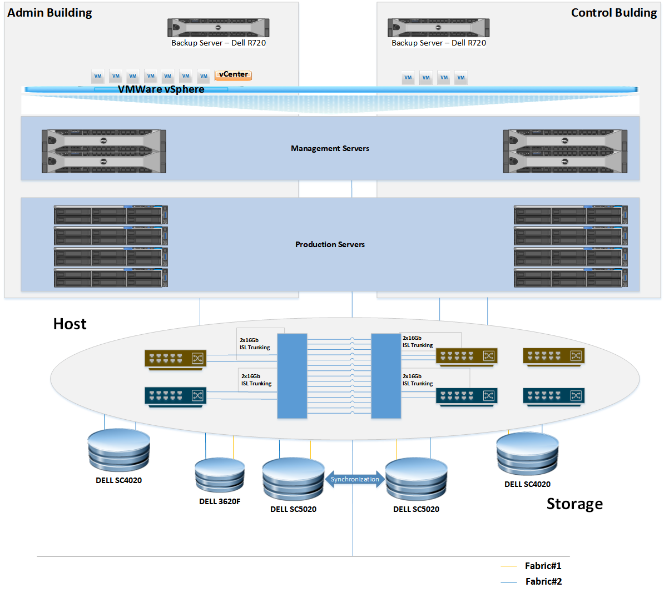

To be

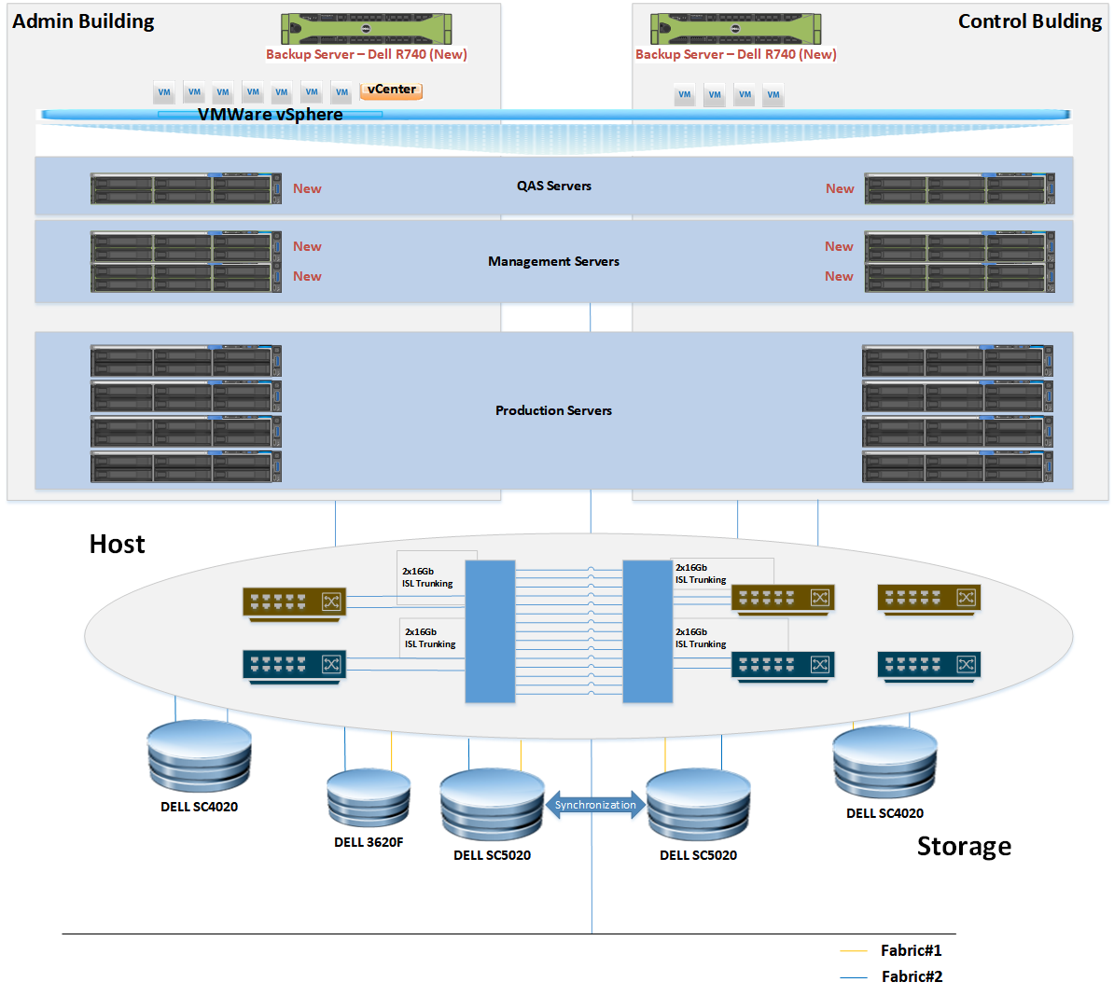

The sizes, quantities, software version, engineering service… indicated in the requirements set out in this Scope of Work will be used as guideline only. The Service providers shall re-size and verify all quantities and dimensions during the detailed design. The Service providers must optimize the requirements with respect to safety, operability, reliability, and life-cycle costs of the provided services set out in this Scope of Works and submit to NSRP for approval. Any deviation to the Original Requirements shall require NSRP’s approval prior to implementation.

Bill of Material
It is requested Service providers to provide flowing equipment

No | Description | Unit | Q.ty
1 | PowerEdge R740 Server[AD SRV] | Pack | 1
 | PowerEdge R740/R740XD Motherboard |  | 1
 | Intel Xeon Gold 6240 |  | 2
 | 2.5 Chassis with up to 8 Hard Drives and 3PCIe slots |  | 1
 | Riser Config 2, 3x16 LP |  | 1
 | 64GB RDIMM, 2933MT/s, Dual Rank |  | 4
 | iDRAC9,Enterprise |  | 1
 | 1.8TB 10K RPM SAS 12Gbps 512n 2.5in Hot-plug Hard Drive |  | 8
 | PERC H740P RAID Controller |  | 1
 | Dual, Hot-plug, Redundant Power Supply (1+1), 750W |  | 1
 | Broadcom 5720 Quad Port 1GbE BASE-T, rNDC |  | 1
 | ReadyRails Sliding Rails With Cable Management Arm
 | Basic Next Business Day 36 Months-Emerging DBS |  | 1
 | ProSupport Plus and Next Business Day Onsite Service Initial-Emerging DBS, 36 Month(s) |  | 1
 | ProSupport Plus and Next Business Day Onsite Service Extension-Emerging DBS, 24 Month(s) |  | 1
2 | PowerEdge R740 Server[BACKUP SRV] |  | 2
 | PowerEdge R740/R740XD Motherboard |  | 1
 | Intel Xeon Silver 4215 2.5G, 8C/16T, 9.6GT/s, 11M Cache, Turbo, HT (85W) DDR4-2400 |  | 2
 | Chassis with up to 8 x 2.5" SAS/SATA Hard Drives for 2CPU Configuration |  | 1
 | Riser Config 3, 2 x8, 3 x16 slots |  | 1
 | 16GB RDIMM, 2933MT/s, Dual Rank |  | 4
 | iDRAC9,Enterprise |  | 1
 | 600GB 10K RPM SAS 12Gbps 512n 2.5in Hot-plug Hard Drive |  | 4
 | Emulex LPE 31002 Dual Port 16Gb Fibre Channel HBA, PCIe Full Height |  | 2
 | PERC H730P RAID Controller, 2GB NV Cache, Adapter, Low Profile |  | 1
 | Dell EMC PowerEdge SFP+ SR Optic 10GbE 850nm |  | 4
 | Dual, Hot-plug, Redundant Power Supply (1+1), 750W |  | 1
 | PowerEdge R740/R740XD CE Marking, APCC, for 1300W PSU below |  | 1
 | Broadcom 57412 Dual Port 10GbE SFP+ & 5720 Dual Port 1GbE BASE-T rNDC |  | 1
 | Broadcom 57412 Dual Port 10GbE SFP+ Adapter, PCIe Full Height |  | 1
 | ReadyRails Sliding Rails With Cable Management Arm
 | Basic Next Business Day 36 Months-Emerging DBS |  | 1
 | ProSupport Plus and Next Business Day Onsite Service Initial-Emerging DBS, 36 Month(s) |  | 1
 | ProSupport Plus and Next Business Day Onsite Service Extension-Emerging DBS, 24 Month(s) |  | 1
3 | LTO6 Tape Media, 5 Pack, Cust Kit |  | 20
4 | Kit - Dell(TM) LTO6 Tape Media Label 401-600 |  | 1
5 | LTO Tape Cleaning Media with Barcode, Cust Kit |  | 6
6 | PowerEdge MX740C Server[Management Servers + QAS Server (Blade)] |  | 6
 | Intel Xeon Gold 6248 2.5G, 20C/40T, 10.4GT/s, 27.5M Cache, Turbo, HT (150W) DDR4-2933 |  | 2
 | 2.5" Chassis with up to 6 SAS/SATA/NVMe Hard Drives MLK |  | 1
 | 64GB RDIMM, 2933MT/s, Dual Rank |  | 16
 | iDRAC9,Enterprise |  | 1
 | 240GB SSD SATA Mixed use 6Gbps 512e 2.5in Hot-Plug S4610 Drive |  | 2
 | PERC H730P RAID Controller |  | 1
 | QLogic FastLinQ 41262 Dual Port 10/25GbE Mezzanine Card with Storage Offloads (iSCSI, FCoE) |  | 1
 | Basic Next Business Day 36 Months-Emerging DBS |  | 1
 | ProSupport Plus and Next Business Day Onsite Service Initial-Emerging DBS, 36 Month(s) |  | 1
 | ProSupport Plus and Next Business Day Onsite Service Extension-Emerging DBS, 24 Month(s) |  | 1
7 | PowerEdge R740 Server[DMZ SRV] |  | 2
 | PowerEdge R740/R740XD Motherboard |  | 1
 | Intel Xeon Silver 4216 2.1G, 16C/32T, 9.6GT/s, 22M Cache, Turbo, HT (100W) DDR4-2400 |  | 2
 | Chassis with up to 8 x 2.5" SAS/SATA Hard Drives for 2CPU Configuration |  | 1
 | Riser Config 3, 2 x8, 3 x16 slots |  | 1
 | 64GB RDIMM, 2933MT/s, Dual Rank |  | 4
 | iDRAC9,Enterprise |  | 1
 | 240GB SSD SATA Mixed Use 6Gbps 512e 2.5in Hot Plug S4610 Drive |  | 2
 | Emulex LPE 31002 Dual Port 16Gb Fibre Channel HBA, PCIe Full Height |  | 2
 | PERC H740P RAID Controller, LP Adapter |  | 1
 | Dual, Hot-plug, Redundant Power Supply (1+1), 750W |  | 1
 | Broadcom 5720 Quad Port 1GbE BASE-T, rNDC |  | 1
 | Broadcom 5719 Quad Port 1GbE BASE-T Adapter, PCIe Full Height |  | 1
 | ReadyRails Sliding Rails With Cable Management Arm |  | 1
 | Basic Next Business Day 36 Months-Emerging DBS |  | 1
 | ProSupport Plus and Next Business Day Onsite Service Initial-Emerging DBS, 36 Month(s) |  | 1
 | ProSupport Plus and Next Business Day Onsite Service Extension-Emerging DBS, 24 Month(s) |  | 1
8 | Dell EMC NX3240[New storage (for user data backup] |  | 1
 | PowerEdge R740/R740XD Motherboard |  | 1
 | Intel Xeon Silver 4208 2.1G, 8C/16T, 9.6GT/s, 11M Cache, Turbo, HT (85W) DDR4-2400 |  | 2
 | Chassis with up to 12 x 3.5" HDDs on BP, 4 x 3.5" HDDs on MP and 2 x 3.5" HDDs Flexbay, 1 and 2CPU Configuration |  | 1
 | PowerEdge 2U LCD Bezel |  | 1
 | Riser Config 2, 3 x8, 1 x16 slots |  | 1
 | 8GB RDIMM, 2666MT/s, Single Rank |  | 4
 | iDRAC9,Enterprise |  | 1
 | 2.4TB 10K RPM SAS 12Gbps 512e 2.5in Hot-plug Hard Drive, 3.5in HYB CARR |  | 12
 | 2.4TB 10K RPM SAS 12Gbps 512e 2.5in Internal Hard Drive, 3.5in HYB CARR |  | 4
 | 600GB 10K RPM SAS 12Gbps 512n 2.5in Flex Bay Hard Drive, 3.5in HYB CARR |  | 2
 | PERC H730P RAID Controller, 2GB NV Cache, Mini card |  | 1
 | Dual, Hot-plug, Redundant Power Supply (1+1), 750W |  | 1
 | Windows Storage Server Standard Edition |  | 1
 | Broadcom 5720 Quad Port 1GbE BASE-T, rNDC |  | 1
 | Windows Storage Servers 2016 Standard Edition |  | 1
 | ReadyRails Sliding Rails With Cable Management Arm |  | 1
 | Limited Warranty:Yr1-3 (Parts)-Emerging DBS |  | 1
 | Yr1-3 ProSupport:Next Business Day Onsite Service-Emerging DBS |  | 1
 | 5Yr ProSupport:Next Business Day Onsite Service-Emerging DBS |  | 1
 | Yr4-5 ProSupport:Next Business Day Onsite Service-Emerging DBS |  | 1
 | 5Yr ProSupport:(7x24) Technical Support & Assistance-Emerging DBS |  | 1
8.1 | Intel X710 Dual Port 10Gb Direct Attach, SFP+,PCIe Full Height, Cuskit |  | 1
8.2 | SFP+ SR Optic for all SFP+ ports except high temp validation warning cards customer install |  | 2

Implementation
- The Service provider undertakes the safety induction training, permit to works, material, labor, supervision, inspection, testing and documentation of all required permanent works to complete project to comply with NSRP requirements.
- The Service provider is responsible for installation provided equipment including installing servers, configuring new system, physical wiring, tagging connections… without system down time.
- Service provider will NOT tamper with the existing infrastructure without NSRP’s explicit permission.
- Service provider is responsible for testing completed System to confirm all connections/ configuration working well before replacement and minimize potential risk to NSRP System.
- Service provider is responsible for providing all needed documents, solution for migration servers, data backup … to minimize interruption during implementation.
- The Service provider must test all System after implementation to make sure whole System is stable after changing.
- The Service provider is responsible for update all detail design documents before hand over to NSRP

Site Survey
- Service providers shall cooperate with NSRP to carry out a survey at NSRP Site to evaluate the current system, collect information about configuration, backup policies, number connections, data flow, physical connections… to identify the Final Requirements and give proper solution
- After completion of the survey, the results of the site survey will be delivered to NSRP along project planning and all design documents detailing for improving network system.

Technical document and diagram
- The Service providers shall provide all specification documents of the provided products (Server, storage datasheet, equipment / back up configuration guide…)
- NSRP shall provide Service provider current physical diagram, logical diagram, IP planning and any needed information for detail design and built implantation plan. This information is provided without NSRP assuming any responsibility for its accuracy. The Service provider must independently verify all information that it wishes to rely upon and is solely responsible for the consequences of any of such information being inaccurate.
- Service provider is responsible for design new system (Survey report, Detail design, Physical diagram, and Logical diagram, migration procedures), implementation documents, migration planning, and checklist for implementation, System operation guide.
- Service providers shall follow NSRP’s procedure to prepare for Production servers implementation (Permit to Work, Method Statement, Job Safety Analysis…).

Equipment, tools and PPE for implementation

The Service providers shall provide all equipment, tools and materials necessary for performance of the Works, including but not limited to:

No | Equipment, tools and PPE
1 | Electric equipment (Terminal Box, Electric tester…)
2 | Hand tools (screw drivers, plier, LAN cutter, floor puller …), Tagging Machine
3 | UTP Cat 6 Cable, Console Cable, Electrical wire
4 | Fiber Optic Tester Machine
5 | Personal Protect Equipment (Head Protection, Gloves, Eye Protection, Flame Retardant Suit…)

Warranty
- Goods: The Contractor shall provide 5 years of warranty for provided equipment

Project management
- Service providers is responsible for providing all management services necessary for proper execution of the Works in order to ensure the Works is completed on schedule and in strict compliance with the NSRP’s Requirements of the Contract. This shall include but not be limited to the followings: Assign person in charge for all activities in a timely manner in accordance with the requirements of the Works.
- Take necessary corrective action to align the Works and the Project back on track in case of deviations from plans (cost, schedule, quality, HSE, performance, operability, maintainability, etc.) including mobilizing additional resources as required.
- Maintain record of all notices, correspondence, reports, documents, etc. during the course of execution of the Works. Ensure that the Engineering Records are maintained for the duration stipulated in the Contract.
- Follow a complete set of Management, Co-ordination, Execution, Quality System and HSE procedures which prepared by NSRP and ensure that the approved procedures are complied with by all concerned.
- Co-ordinate and control the work of Service provider’s specialist departments, e.g. Engineering, Design, Procurement, Project Controls, Contracting, Construction and Commissioning, HSE, QA/QC, and others disciplines to ensure that the Works are completed on Schedule and in accordance with the requirements of the Contract.

Hand-over, Training and Technical transfer
- The Service Provider is responsible for updating and hand over all documents related to network/security diagram after finishing implementation.
- The Service Provider is responsible for hand over all information of software, license and accounts related to project after finishing implementation.
- The Service Provider is responsible for training NSRP System staffs in 3 days.

Requirement for Contractor
To ensure project will be implemented with right method and high quality, NSRP requires Service providers must have the following requirements:
- The Service provider has to have at least 1 years of experience in providing and implementing VM virtualization, DELL blade server, Veritas backup products by providing at least 02 similar completed contracts.
- The Service Provider must provide BOM certified by DELL
- The Service Provider must provide certificates of DELL’s Partners/ Distributor
- The Service Provider is requested to provide at least 01 engineer with VMWare VCP6 certificate .

